Artisan Beauties

Natural Surfaces von Scheurich

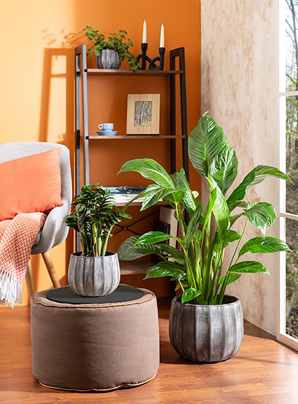
Furnishings with original materials and lively surfaces are very popular. Coarse linen fabrics, not quite smoothly polished wood and selected accessories emphasise the individual living ambience.

With ‘Natural Surfaces’, Scheurich presents a new collection of handcrafted cover pots with a thick-walled, high-quality design.

Runa fascinates with its tactile experience and the hand-finished three-dimensional surfaces. With the Washed Grey and Washed Cream decors, the planters offer plenty of scope for arrangements with Zamioculcas or Spathiphyllum.

The Dune series is characterised by originality and authentic structures - here too, each piece is unique. An exotic leaf begonia (Begonia Hawaiian Silver) enhances the effect of the Washed Cream and Washed Brown decors.

Beautiful to touch! Mavi impresses with a relief pattern that creates attractive light and shadow effects. The alabaster-coloured cachepots with the characteristic base are also the perfect setting for precious orchids such as Phalaenopsis bolgheri.

Alva combines stripes and natural colours in their most beautiful form. The smooth, slightly glossy surface and the subtle Sunstone decor harmonise beautifully with a basket maranthea (Calathea Insignia) or a dwarf pepper (Peperomia).

Handmade look in proven Scheurich quality: the ceramic pots with their organic shapes are naturally waterproof.

Available sizes:
Runa (Washed Grey, Washed Cream):
14, 17, 20, 25 and 31 cm
Mavi (Alabaster): 13, 16 and 19 cm
Alva (Sunstone): 13, 16 and 19 cm
Dune (Washed Brown, Washed Cream):
13, 16 and 19 cm

