# Be happy!

## **Fun Fiesta from Scheurich**

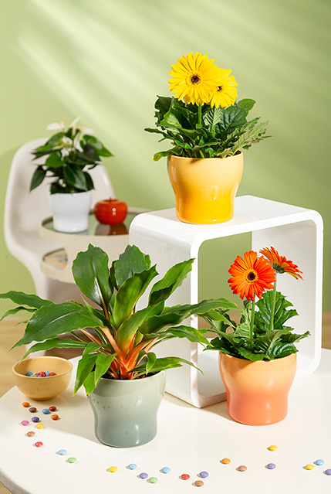Colourful bubbles are fun! And the more of the colourful bulbs that appear in everyday life, the better. The popular shape has long been an integral part of vases, lamps and other home accessories and Scheurich is also celebrating this hype: Fun Fiesta is the new cover pot series that ensures a good mood from morning to night with cheerful colours, making a wonderful statement for a positive attitude in the current challenging times.

The stylish cover pots in the colours Sunrise, Sunset, Sea Green and Alaska are shaped like bubbles. The glossy surface in combination with the colour gradient presents the bubbles trend at its best. Fun Fiesta makes your heart light and brings a smile to your face. The flower pots spread this little happiness every day - both individually and as arrangements on the windowsill, on sideboards or on side tables.

If you want to extend the colourful fun, add plants such as yellow or orange gerbera, green lily ‘Green Orange’ (Chlorophytum) or a flamingo flower (Anthurium) to Fun Fiesta. The lush green of the plants complements the festival of colours in an atmospheric way. Fun Fiesta has a softly coloured effect, especially when light falls on it, emphasising the modern touch of a lovingly designed living ambience.

Fun Fiesta is Made in Germany and 100 % waterproof.

|  |
| --- |
| Available sizes: |
| 13, 15 and 18 cm |

## **About Scheurich**

My pot. My style.

## Scheurich knows how to meet different customer demands and to offer fashionable products for current trends in interior styles. With designs at the pulse of the time, proven quality Made in Germany and one of the largest offerings of shapes in the market, the family business is the No. 1 in Europe when it comes to plant containers for the in- and the outdoors. The sustainable ceramics and plastics production lines at the German locations make Scheurich a pioneer of environmental protection. The company is part of the Scheurich-Group and will be carbon neutral in its plants by 2035.