Magic and tradition

Mystic from Scheurich
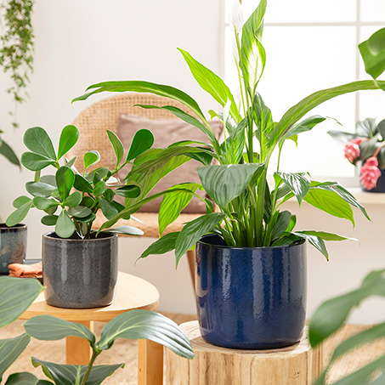
Scheurich reveals the latest secret: the Solido cover pots are now also available in Mystic Blue and Mystic Grey. The high-quality design is combined with a magical look to create a wonderful overall impression that stands out charmingly from other series and therefore looks a little like something from other spheres.

The shimmering shades of blue in Mystic Blue are reminiscent of auroras on a dark night, while Mystic Grey takes on the power of stones. Mystic is grounded by the ceramic materiality and the thick-walled handcrafted style, which is finished to natural perfection with a colour gradient right up to the rim. Each planter is unique with a great glazed look.

If you have such an effect, you can also show it on a grand scale: Mystic is available up to XL size for impressive houseplants and the various sizes are a wonderful match for a balsam apple (Clusia rosea), monocot (Spathiphyllum), Medinilla or a Strelitzia. In the living room, Mystic prefers to be placed next to ceramic tableware, wooden elements and light and bright components as a balance to the rich colours.

Whether arranged tone-on-tone, as a duo or combined with other Solido cover pots, Mystic Blue and Mystic Grey allow plenty of creative freedom. With the new planters, plant lovers can live out their undiscovered talents in their individual urban jungle.

Mystic is made in Germany and 100 percent waterproof.

Available Sizes:
13, 15, 18, 21, 24 and 28 cm

About Scheurich

My pot. My style.
Scheurich knows how to meet different customer demands and to offer fashionable products for current trends in interior styles. With designs at the pulse of the time, proven quality Made in Germany and one of the largest offerings of shapes in the market, the family business is the No. 1 in Europe when it comes to plant containers for the in- and the outdoors. The sustainable ceramics and plastics production lines at the German locations make Scheurich a pioneer of environmental protection. The company is part of the Scheurich-Group and will be carbon neutral in its plants by 2035.

