Italian way of life - Made in Germany

**La Natura from Scheurich**

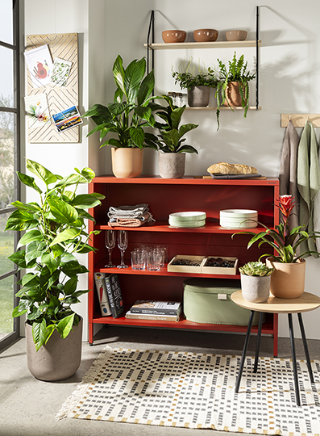Ciao Bello! Scheurich presents three classic beauties in the La Natura cover pot series. With Basalto, Travertino and Rosso, however, it is a little difficult to choose a favourite. Scheurich offers a charming solution: Decorated as a trio or in larger arrangements in a natural living environment, Basalto, Travertino and Rosso look particularly attractive.

La Natura impresses with its soft shape design, natural colours and unique matt finish, as if brought straight from Tuscany. Scheurich shows originality interpreted with style. Inspired by Italian stone types, La Natura creates a cosy atmosphere with plants such as an ivy lily (Epipremnum), a fig tree (Ficus lyrata) or a Guzmania.

Basalto, Travertino and Rosso are characterised by their natural ceramic material with 22 percent recycled content. With its broken-up structure, Basalto has a very striking effect. Travertino favours a marble look with typical irregularities and Rosso flirts with a characteristic terracotta look. The darker, glossy interior colours stand out from the matt surfaces and guarantee 100 percent waterproofness.

All cover pots are also available with a large diameter for XL plants. Because La Dolce Vita knows no limits!

|  |
| --- |
| Available Sizes: |
| 13, 15, 18, 21, 24 and 28 cm |

## **About Scheurich**

My pot. My style.

Scheurich knows how to meet different customer demands and to offer fashionable products for current trends in interior styles. With designs at the pulse of the time, proven quality Made in Germany and one of the largest offerings of shapes in the market, the family business is the No. 1 in Europe when it comes to plant containers for the in- and the outdoors. The sustainable ceramics and plastics production lines at the German locations make Scheurich a pioneer of environmental protection. The company is part of the Scheurich-Group and will be carbon neutral in its plants by 2035.