# Indoor goes Outdoor

## **Linetto by Scheurich**

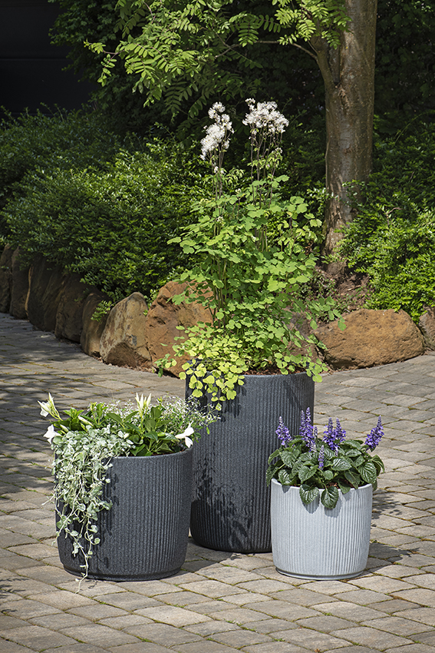Linetto by Scheurich is the perfect choice for all those looking for a new design for their indoor or outdoor areas. The new planters feature the vertical grooves of the popular Solido Linea indoor planter making them the perfect fit for your garden. These matching planters compliment your household, whether indoors or outdoors, making you feel right at home.

Whether as a set or on its own, Linetto in Stony Black and Stony Grey blends stylishly into the outdoor ambience with its modern and natural design. Connoisseurs cannot resist this line with their grooved profile underlines creating that sleek, yet handcrafted look. The planters give you a lively, light, three-dimensional surface, finished with a thick-walled texture. Linetto accentuates any patio and creates a visual setting for plants such as Columbine (Thalictrum Aquliegiifolium), Magic Snow (Chamaesyce Hypericifolia), Silver Rain (Dichondra Argentea) or Mealy Sage (Salvia Farinacea).

Made of the high-quality recyclable plastic Garduro, Scheurich is a leading force in the industry when it comes to waste and recycling. Made in Germany, this plastic is manufactured with the highest percentage of recycled materials, is UV and frost resistant and comes with a 10-year guarantee.

Linetto is available in the Linetto and Linetto High models. All containers are equipped with a closable water drain. When the closure is open, there is no waterlogging; when tightly closed, Linetto easily finds its place inside the home for winter without leaving any surface marks. For easy planting, the high pot comes with an integrated plant insert.

Tip: If you want to try something new next year, place Linetto High at the entrance to your house. Welcome all along the line!

|  |
| --- |
| Available sizes: |
| Planters: 30, 40 and 47 cm |
| Tall container: 54 cm |



## **About Scheurich**

My pot. My style.

Scheurich knows how to meet different customer demands and to offer fashionable products for current trends in interior styling. With its fingers on the pulse of design, proven quality ‘Made in Germany’ and one of the largest offerings of shapes in the market, the family business is No. 1 in Europe when it comes to plant containers for both the indoors and out. The sustainable ceramics and plastics production lines at both German locations make Scheurich a pioneer of environmental protection. The company is part of the Scheurich Group and will be carbon neutral in its plants by 2035.