A glamorous appearance

Orchid pots from Scheurich

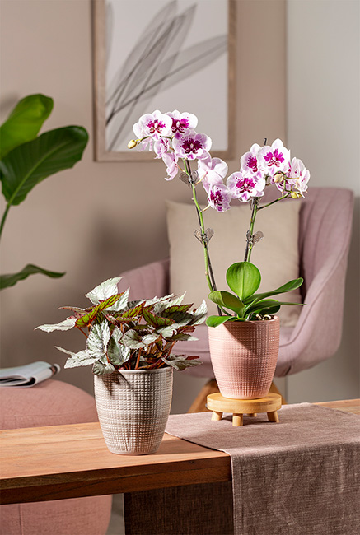
Orchids are faithful companions! Scheurich honours this timeless character with new orchid pots in the colours Lychee and Glass Taupe from the Corteza range. Trendsetters can stylishly complement the modern living ambience with natural materials such as linen, felt and wood.

The colours structure of Corteza, reminiscent of a coarse linen fabric, blends elegantly into the overall picture, while the indentations conjure up an iridescent look butterfly orchids (Phalaenopsis aladdin) or a Zygopetalum orchid. Zygopetalum orchid to create a highlight in the room. In combination with the colours Lychee and Glass Taupe, the transition from the pot to the delicate orchid looks orchid appears to be softly drawn. In beautiful contrast to this is the thick-walled, handcrafted design of Corteza.

The orchid pots are a perfect match for the floral wonders of nature, and not just on the outside. The pots are designed so that the roots do not come into contact with excess irrigation water. Soft water - such as rainwater in well-dosed quantities - is ideal for care.

Tip: Orchid sticks and orchid clips prevent the flower panicles from kinking as they become heavier over time. Under the right conditions, the expressive splendour of the flowers can be enjoyed up to twice a year.

Plant fans can complement the new products with orchid pots in the colours Vainilla, Menta, Pimienta and Alaska or other flower pots and bowls from the Corteza series. The orchid pots themselves also create a beautiful arrangement with other plants such as a leaf begonia (Begonia Beleaf) or a sickle fern (Cyrtomium falcatum).

Corteza is Made in Germany and 100 per cent waterproof.

Available sizes:
Orchid pot: 15 cm
Orchid stick
Orchid clip (set of 2)

About Scheurich

My pot. My style.
Scheurich knows how to meet different customer demands and to offer fashionable products for current trends in interior styles. With designs at the pulse of the time, proven quality Made in Germany and one of the largest offerings of shapes in the market, the family business is the No. 1 in Europe when it comes to plant containers for the in- and the outdoors. The sustainable ceramics and plastics production lines at the German locations make Scheurich a pioneer of environmental protection. The company is part of the Scheurich-Group and will be carbon neutral in its plants by 2035.

