Popular cover-pot shape. New trend colour.

Sage Green from Scheurich

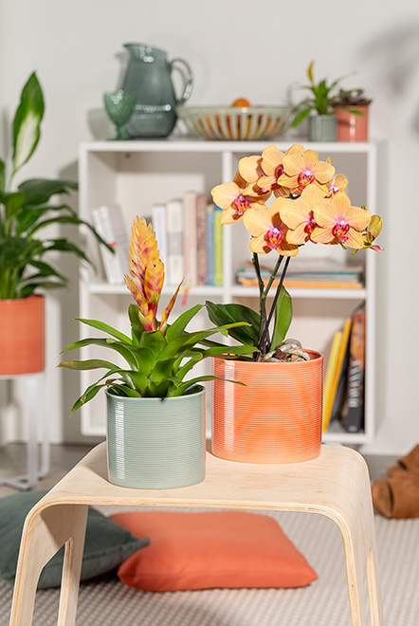
Sage is now also visually effective: the Sage Green cover-pot from Scheurich has a fascinating effect on its surroundings - Sage Green revitalises any room and sets modern accents.
With the yellowish-red blossom of the Vriesea, floral aesthetes pick up on the colour scheme of the Papaya planter, which combines beautifully with Sage Green. A butterfly orchid (Phalaenopsis) with orange-coloured flowers completes the overall picture.
Scheurich is constantly reinventing the colours of its classic cylindrical cover-pot. Trend colours such as Zabaione and Papaya are now followed by the popular colour Sage Green, inspired by the green of the sage plant. Like the other colours, Sage Green fits perfectly into a bright, young living environment with white and grey accessories and furniture as well as wooden elements. The pronounced grooved look reinforces the clear lines in this setting. Depending on the incidence of light, the colours on the multi-faceted surface appear lighter or darker.

The unusual colour makes Sage Green an attractive addition to the fresh Papaya and Zabaione shades. It also makes a great gift for loved ones.

Sage Green is made in Germany and 100 % waterproof.

Available Sizes:
12, 14, 16 and 19 cm

About Scheurich

My pot. My style.
Scheurich knows how to meet different customer demands and to offer fashionable products for current trends in interior styling. With its fingers on the pulse of design, proven quality ‘Made in Germany’ and one of the largest offerings of shapes in the market, the family business is No. 1 in Europe when it comes to plant containers for both the indoors and out. The sustainable ceramics and plastics production lines at both German locations make Scheurich a pioneer of environmental protection. The company is part of the Scheurich Group and will be carbon neutral in its plants by 2035.

