Just like in paradise

Tucano from Scheurich
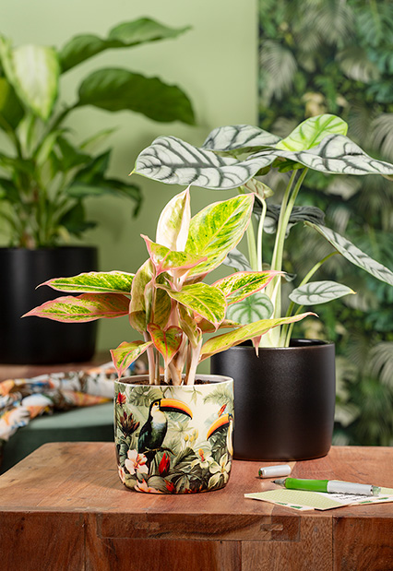
An exciting new discovery in the urban jungle: Tucano from Scheurich adds a colourful example to the variety of cover-pots for the modern home. Magnificent toucans in a beautiful rainforest flora give the indoor jungle an extravagant touch, which has a very aesthetic effect thanks to the textile look of Tucano.

The thick-walled cover-pot shape perfectly frames the lively world of Tucano motifs and makes you want to create expressive arrangements. As a duo with the Ebano or Solare Solido cover-pots, the colours and realistic details of Tucano really come into their own. Scheurich celebrates the colourful mix at its best.

The urban jungle continues to grow authentically with an Aglaonema, Elephant’s Ear (Alocasia) or Peace Lily (Spathiphyllum) and also takes over the furniture and walls: Wallpaper with leaf motifs, green elements and matching fabrics create feel-good oases to recharge your batteries.

An innovative polyprint production process emphasises the high-quality character of the cover-pots with Scheurich's typical Made in Germany and 100 % waterproof quality standards.

Available Sizes:
13 and 15 cm

About Scheurich

My pot. My style.
Scheurich knows how to meet different customer demands and to offer fashionable products for current trends in interior styles. With designs at the pulse of the time, proven quality Made in Germany and one of the largest offerings of shapes in the market, the family business is the No. 1 in Europe when it comes to plant containers for the in- and the outdoors. The sustainable ceramics and plastics production lines at the German locations make Scheurich a pioneer of environmental protection. The company is part of the Scheurich-Group and will be carbon neutral in its plants by 2035.

