Ceramic pots and wicker baskets

Living with plants - naturally with Scheurich
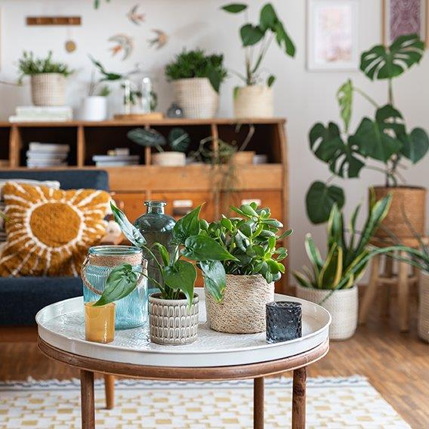
Passionate plant fans are flourishing in the trend for natural materials and are allowing the urban jungle to grow in all possible (style) directions in their own living environment with great attention to detail.

Scheurich's large range is ideal for the motto ‘more is more’. The appeal of the modern urban jungle lies in the deliberate mix of styles and materials. Green living enthusiasts can let off steam creatively with the Solido ceramic cover-pots in smooth and ribbed versions, Lagom in Opale and Luna decors and various wicker baskets made of seagrass or water hyacinth.

There are wicker baskets with and without handles, coarsely woven or more delicately woven and in one or two colours. The handcrafted touch plays a major role in everything. This also applies to the Lagom ceramic cover-pots: Opale is new and just as inspired by nature as the popular Luna cover-pot - gemstones and the moon have always had a strong attraction for people. Do it yourself queens use this magic to create a feel-good atmosphere and use this natural cosiness as the connecting element between Crassula, copper arrow leaf (Alocasia cucullata), dragon tree (Dracaena) and Monstera deliciosa.

Nature and the Scheurich range continue to grow and with them the desire for Urban Jungle XL. Only the watering water is limited by the watertight baskets and ceramic cover-pots - nothing leaks here.

Available Sizes:
Cover-pots Lagom:
10, 12, 14, 16 and 19 cm
Cover-pots Solido:
13, 15, 18, 21, 24 and 28 cm
Cover-pots Solido Linea:
13, 15, 18, 21, 24 and 28 cm
Wicker baskets seagrass (Nut, Brown, Green, Nature):
13, 15, 17, 19, 22, 24 and 26 cm
Wicker baskets seagrass (White, Black):
15, 17, 22, 24 and 32 cm
Wicker baskets seagrass with handle (White, Black):
22, 26, 32 and 36 cm

About Scheurich

My pot. My style.
Scheurich knows how to meet different customer demands and to offer fashionable products for current trends in interior styles. With designs at the pulse of the time, proven quality Made in Germany and one of the largest offerings of shapes in the market, the family business is the No. 1 in Europe when it comes to plant containers for the in- and the outdoors. The sustainable ceramics and plastics production lines at the German locations make Scheurich a pioneer of environmental protection. The company is part of the Scheurich-Group and will be carbon neutral in its plants by 2035.

